Chapter 19, Solution 4.

Using Fig. 19.68, design a problem to help other students to better understand how to determine z parameters from an electrical circuit.

Although there are many ways to solve this problem, this is an example based on the same kind of problem asked in the third edition.

Problem

Calculate the z parameters for the circuit in Fig.19.68.

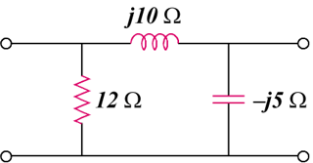

Figure 19.68

Solution

Transform the  network to a T network.
Z₃
Z₂
Z₁

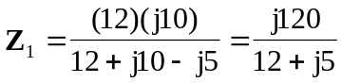
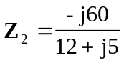
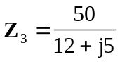

The z parameters are
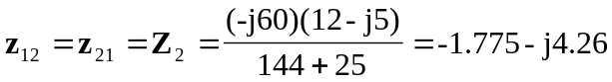

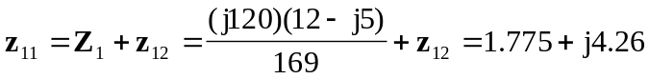

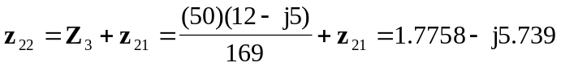

Thus,
